
BEACONHOUSE NATIONAL UNIVERSITY

Assignment no 1
Course Instructor: Muhammad Raheel Iqbal Butt
Section: B & C |  | Program: BS (CS) |  |  | Submission Date: June 3, 2026 & June 5, 2026.
Course Title: Professional Practices |  | Course Code: HUM-305 |  |  | Semester : Spring 2026
Time Allowed: 1 week |  |  | Total Marks: 10
CLO 1, 2,3,4,5,6,7,8,9 | PLO 1,2,3,4,5,6,7,8,9 |  |  | CO 1,2,3,4,5,6,7,8,9
TO BE FILLED IN BY THE STUDENT
Student Name: Registration No: Group
1:

2:

3:

4:

5:

TO BE FILLED IN BY THE RESOURCE PERSON
General Remarks & Evaluated Marks:

Resource Person Signature

Assignment Title:
Develop a Comprehensive Mind Map on Professional Practices in Your Field

Objective:
The purpose of this assignment is to enable you to understand the fundamental concepts of professional practices, ethical responsibilities, workplace standards, leadership qualities, legal obligations, technological advancements, and professional development required in modern organizations.

Assignment Instructions
Create a detailed mind map illustrating the major dimensions of Professional Practices. Your mind map should be visually attractive, logically connected, and supported with relevant examples from real organizations and industries.

Central Theme:
Professional Practices

Main Branches of the Mind Map

1. Professional Ethics
- Integrity
- Honesty
- Accountability
- Transparency
- Confidentiality
- Professional Conduct
- Ethical Decision Making
- Conflict of Interest Management

2. Professional Communication
- Verbal Communication
- Written Communication
- Digital Communication
- Presentation Skills
- Active Listening
- Interpersonal Skills
- Negotiation Skills
- Cross-Cultural Communication
- Professional Emails
- Business Reports
- Team Meetings
- Client Presentations

3. Leadership and Teamwork
- Leadership Styles
- Team Collaboration
- Conflict Resolution
- Motivation
- Delegation
- Decision Making
- Emotional Intelligence
- Change Management
- Project Team Leadership
- Managing Diverse Teams
- Organizational Coordination

4. Workplace Professionalism
- Time Management
- Discipline
- Workplace Etiquette
- Dress Code
- Responsibility
- Reliability
- Commitment to Quality
- Respect for Diversity
- Meeting Deadlines
- Professional Behavior at Workplace
- Respecting Organizational Policies

5. Legal and Regulatory Compliance
- Labor Laws
- Professional Standards
- Industry Regulations
- Intellectual Property Rights
- Copyrights
- Data Protection
- Occupational Health & Safety
- Compliance with Organizational Policies
- Workplace Safety Procedures
- Legal Documentation

6. Project and Risk Management
- Planning
- Scheduling
- Resource Allocation
- Risk Assessment
- Quality Assurance
- Monitoring & Evaluation
- Continuous Improvement
- Construction Projects
- Software Development Projects
- Business Expansion Projects

7. Technology and Innovation
- Artificial Intelligence
- Digital Transformation
- Automation
- Data Analytics
- Cyber security
- Emerging Technologies
- Innovation Management
- AI in Business Operations
- Smart Manufacturing
- Digital Workplaces

8. Sustainability and Social Responsibility
- Environmental Responsibility
- Corporate Social Responsibility (CSR)
- Sustainable Development Goals (SDGs)
- Community Engagement
- Ethical Business Practices
- Green Technologies
- Renewable Energy Projects
- Social Welfare Programs
- Sustainable Business Models

9. Global Professional Practices
- International Standards
- Globalization
- Multicultural Work Environment
- Remote Work Culture
- International Collaboration
- Global Ethics
- Multinational Companies
- International Projects
- Global Virtual Teams

Mind Map Design Requirements
- Use at least 10 major branches.
- Include minimum 5 sub-branches under each main branch.
- Add relevant icons, symbols, and colors.
- Include practical examples where possible.

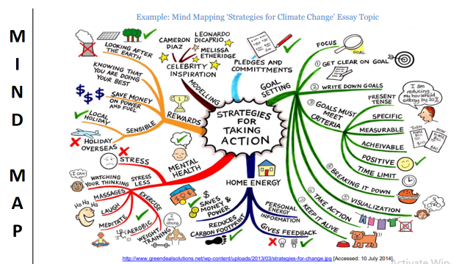
Mind map Example

Group Members Input Sheet
Member 1 Input / Conclusion:
__________________________________________________________________________________________________________________________________________________________________________________________________________________________________________________________________________________________________________________________________________
__________________________________________________________________
Signature
Member 2 Input / Conclusion:
__________________________________________________________________________________________________________________________________________________________________________________________________________________________________________________________________________________________________________________________________________
__________________________________________________________________
Signature
Member 3 Input / Conclusion:
__________________________________________________________________________________________________________________________________________________________________________________________________________________________________________________________________________________________________________________________________________
__________________________________________________________________
Signature
Member 4 Input / Conclusion:
____________________________________________________________________________________________________________________________________________________________________________________________________________________________________________________________________________________________________________________________________________________________________________________________________________
Signature

